USER MANUAL

Engine Simulation and Analysis

Software for Personal Computer Based Numeric Simulation of Engine Performance

Paul Williams
Christie van Vuuren

University of Stellenbosch
1996-2001

Contents
1. Contents 1
2. Introduction 1
3. Disclaimer 1
4. Installation and Setup 2
5. Program and Menu Overview 3
6. Creating an Engine Data File 5
7. Single Point Simulation 17
8. Multi Point Simulation 24
9. General Information 28

Introduction
ESA is an internal combustion engine simulation package written by post-graduate students of the University of Stellenbosch as part of their studies. The simulation package consists of a two-zone thermodynamic combustion model linked to a computation fluid dynamics (CFD) manifold and pipe flow model and integrated with a camshaft analysis model. The combination of these three models allows accurate simulation of all the effects of variation of cam profiles, manifold and exhaust pipe dimensions as well as geometric, fuel and other properties of the engine and its environment. The program was written in Borland Delphi 4 and compiled to a user friendly, full 32 bit Windows 95/98 and NT application.

Disclaimer
The authors, the CAE and the University of Stellenbosch, make no warranty of any kind, expressed or implied, including without limitation any warranties of merchantability and/or fitness for a particular purpose. The authors do not assume any liability for the use of ESA, as will be displayed on initialising the program.
In no event will the authors be liable for any additional damages. This include any lost profits, lost savings, or other incidental or consequential damages arising from the use of, or inability to use, this software and its accompanying documentation, even if the authors have been advised of the possibility of such damages.
Please note that the software is still in the developmental phase. The software has been extensively tested for bugs and other irregularities, but please feel free to report any further errors or suggestions to the author of this thesis or the CAE at email address cae@ing.sun.ac.za.
For quick assistance, please feel free to contact the CAE at +27 – 21 882 8820.

Installation and Setup
The computer installation code is supplied on a CD-ROM disc. The program can be installed on the computer of the user by the standard Windows method of running SETUP.EXE on the CD. This is accomplished either by selecting Start, Settings, Control Panel, Add/Remove Programs and then clicking Install or by selecting Start, Run typing X:\ESA\SETUP.EXE in the open box and then clicking Ok (X is the letter of the appropriate disk drive, normally D for the CD-ROM drive). Once the Install Wizard is running, the user should follow the instructions as given, remembering to type the user details and serial number supplied with the program in the required dialog. ESA installs by default into the C:\ESA directory, but this can be changed by the user if so desired.
The Install Wizard installs the following files into the selected folder of the user. A description of the exact nature of the user adjustable files is given later in this document.
ESA.exe - the executable file to run the program
Default.eng - a default engine setup file
Default.cwt - a default head, piston and liner temperature vs. speed file
Default.spk - a default ignition timing vs. speed file
Default_Inl.maf - a default inlet manifold and pipe geometric profile file
Default_Exh.maf - a default exhaust manifold and pipe geometric profile file
Default.exh - a default exhaust gas temperature and pressure vs. speed file
Default_Inl.cam - a default inlet valve lift profile file
Default_Exh.cam - a default exhaust valve lift profile file
Default_IV.vcd - a default inlet valve C_{d} map (forward flow) file
Default_IVRev.vcd - a default inlet valve C_{d} map (reverse flow) file
Default_EV.vcd - a default exhaust valve C_{d} map (forward flow) file
Default_EVRev.vcd - a default exhaust valve C_{d} map (reverse flow) file
Errorlog.err - a file used to log errors that may occur in the simulation
ESA.ini - a program setup file installed into the C:\Windows directory.
Once the installation has been completed, the user can run the program by clicking on the ESA icon under the Start Menu / Programs folder. No further user setup is required at this time. The program runs best in a screen resolution of 800x600 or 1024x768 with at least 256 colours.

Program and Menu Overview
A short description of the menu items and functions as well as basic operation of the program is given in this section.
On program start-up, the displayed user interface consists of a menu bar, a status bar and four display areas.
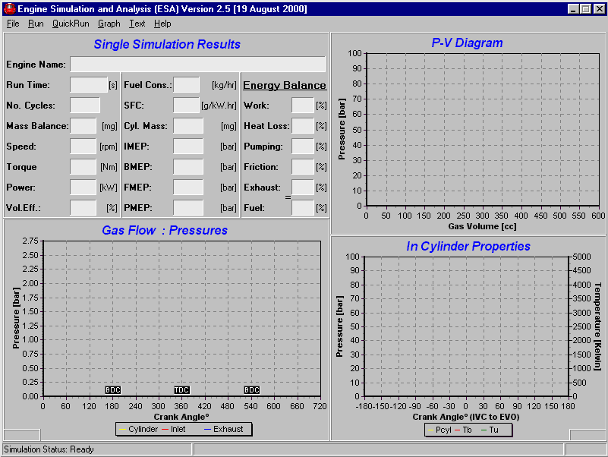
Figure 1: User interface during program start-up
In the top left corner is a multiple text box area where the program reports the results of a single simulation run. Some of the reporting is online while the program is running. Other information is only displayed, as it becomes available at the completion of the simulation.
In the top right corner is a graph that displays an online indicator PV-diagram, cylinder pressure vs. volume for one cylinder. This graph scales automatically unless the user performs a manual scaling as described later in this manual.
In the bottom right corner is a graph providing a trace of in-cylinder properties vs. crank angle. The properties displayed are cylinder pressure (P_{cyl}), mixture burned temperature (T_{b}) and mixture unburned temperature (T_{u}).
In the bottom left corner is a graph that can display the following:
Cylinder conditions: pressure, total trapped mass, unburned mass and burned mass vs. crank angle
Inlet valve conditions: pressure, velocity and mass transfer vs. crank angle
Exhaust valve conditions: pressure, velocity and mass transfer vs. crank angle.
The status bar display information regarding the files loaded or saved by the user as well as the simulation status including crank angle and simulation time elapsed.
The initial available menu items are the following (Figure 1):
File | Run | QuickRun | Graph | Text | Help.
Under the File menu, the user elects to Load, Save and Edit the geometrical and operational details of a desired simulation as well as Exit the program.
The Run menu is used to initialise or Pause and Stop the various simulation modes. Selecting the Single Point Simulation option initialises the simplest simulation mode. To run multiple point simulation runs, choose Multi Point Simulation. These options are executed after an engine file has been loaded.
The QuickRun menu is used to initialise the Single Point Simulation option by loading the default engine data file and configuration.
The Graph menu is used to alter the various parameters that are displayed on the graphs during and after completion of the simulation. Some of the options are only available after an engine file has been loaded. The options are changing Run-Time Graph Options, viewing a Torque Curve, Valve Opening and the Energy Balance during the last engine cycle.
The Text menu is used to view and save (default to Lastcyc.text) the results of a completed simulation. The text format is suitable for use in a spreadsheet e.g. Excel. This provides accurate data for all simulated parameters at each crank angle degree.
The Help menu provides access to this User Manual that serves as a help document and the About box, giving some detail on the software and its creators.

Creating an Engine Data File
This section describes the basic use of the program and creating an engine data file. For the purposes of this tutorial, the user will load the default engine file; modify a few operating parameters and then run a simple simulation.
On initialising the program, the user interface (Figure 1) becomes visible.
To load the engine data files, the user clicks File, Load. The Open Engine Data File dialog box is displayed (). The user can select the desired *.eng files using the standard windows dialog box. Select the file and then click Open.
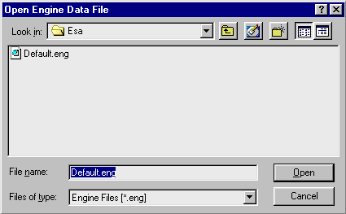
Figure 2: Load engine data file
The loaded filename is displayed in the lower status bar. To load the default engine file automatically, the user clicks File, Load Default.
To modify the engine model input data, click File, Edit. The Edit Engine Data dialog box will be displayed (Figure 2).
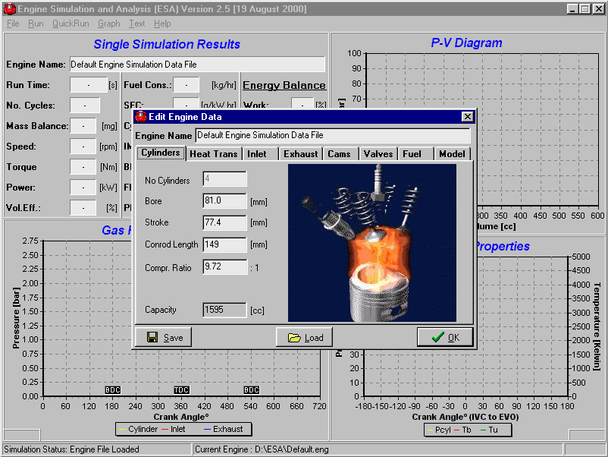
Figure 3: Edit engine data file
To modify any parameter, change the text or value in the edit boxes ( Figure ). Cylinders is the first edit tab to be displayed ( Figure ). The geometric information on the engine can be changed here:
The capacity of the engine is then calculated and displayed as in Figure .
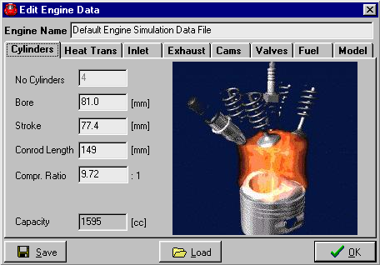
Figure 4: Cylinder data
Heat Trans (heat transfer) is the next edit tab (Figure 4). Here information on the heat transfer of the engine, burn angle and ignition timing of the engine can be changed. The surface temperatures of the head, piston, upper and lower liners are given as an input file to the program via a text file, *.cwt (Figure 5). Different input files are selected by clicking the Browse button. In this file surface temperatures at different engine speeds are given. The format of the text file is the same for all the other input files to the program. The value in the first text line sets the number of data lines in the text file. The second line has headings for all the data sets. The remaining lines, as specified by the value in the first text line, have all the necessary input data for the program.
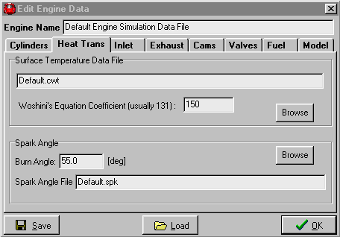
Figure 5: Heat transfer and ignition timing data
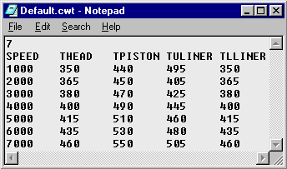
Figure 6: Temperature data for the head, piston and liners
The Woshini’s Equation Coefficient [2] exists to fine-tune the heat transfer in the model. The model is not accurate enough to calculate the heat transfer exactly as in the physical engine. Because of limited information, the model needs to be fine-tuned to get the heat transfer equalling the right percentage loss of the total available energy of the engine. This percentage value can be obtained by doing physical engine tests or by assuming a value of 30 ± 5% [2].
The Burn Angle of the fuel also depends very much on the combustion chamber design of the engine. By doing a full combustion analysis on the engine, the burn angle can be obtained at each engine speed. If this information is not available, a good estimate is a value between 40° - 60° crank angle [2].
The information needed for the Spark Angle File (Figure 6) is usually only obtained after doing physical engine tests. If this is not possible, experience and other similar data from other engines are used to create such a file. The most beneficial timing (MBT) can also be estimated by doing variable ignition timings with the model at the same speed and with the same burn angle. The ignition timing that gives the maximum torque will then be used, until further engine data is available.
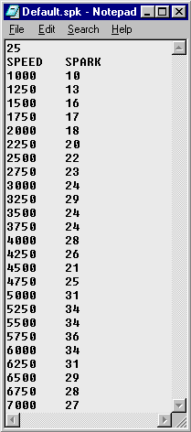
Figure 7: Ignition timing information
Inlet is the next edit tab (Figure 7). In the edit boxes of this tab, all the information on the inlet manifold is displayed. The first information needed is the geometrical detail on the inlet manifold. For this information the program uses an input file that is created by clicking on the Edit button. A new window is displayed that has length and area as input ( Figure ). This data is also displayed as a graph and saved as a text file, *.maf.
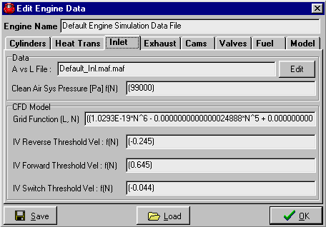
Figure 8: Inlet manifold data
The length of the manifold is taken from the entrance of the plenum (zero point) up to where the inlet valve ports end. The area along this length is then given in small length steps.
Sometimes it is necessary to simplify the area variation in the inlet port. Big area changes can be found in this region, which can lead to simulation instabilities. The simulation program is using a grid to solve the flow in the inlet. If the area change is very big, the grid might not be small enough to take it into account. The grid also changes with engine speed, meaning that sometimes this area change is taken into account and other times not. It is therefore better to keep area variation smooth, as illustrated in Figure 8.
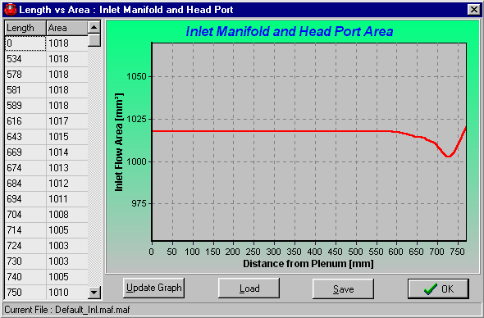
Figure 9: Inlet manifold area vs. length
The next information needed is the Clean Air Sys Pressure. This pressure is part of the boundary condition at the open end to the manifold plenum. In a well-designed inlet manifold this pressure is almost constant, but it will drop slightly as the engine speed increases. This data is usually obtained from engine tests. The pressure is given to the program as an equation, which is a function of engine speed for e.g. (E-10*N^3 - 1E-06*N^2 - 0.0009*N + 1014.4).
The information needed to ensure mathematical stability and smooth transition between forward and reverse flow is displayed in the last four edit boxes, as displayed in Figure 7. The first edit box, Grid Function, is the inlet grid size equation, which is a function of engine speed and inlet length. For each engine model this needs to be fine-tuned by first calculating the grid size using the CFL-stability criterion. The grid size is then tested and corrected by running simulations with a grid size just above and below the CFL calculated grid to correct for velocity changes.
Getting smooth transition between forward and reverse flow at the inlet valves can be very difficult. The pressures at the inlet valve and in the combustion chamber can sometimes be very close together; for example just before the inlet valve closes (described in Chapter 2). To help in the smoother transition between forward and reverse flow, a minimum velocity (trial-and-error based) at the valve is given before the flow will change from forward to reverse, or reverse to forward flow.
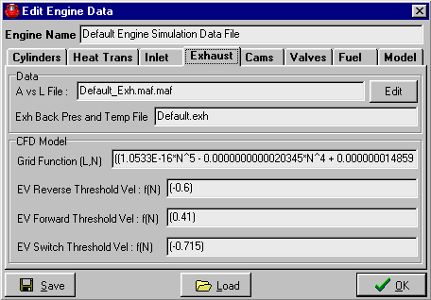
Figure 10: Exhaust manifold data
Exhaust is the next edit tab (Figure 9). In the edit boxes of this tab, all the information on the exhaust manifold and pipe is displayed. The first information needed is the geometrical detail on the exhaust manifold and pipe. For this information the program uses an input file that is created by clicking on the Edit button. A new window is displayed that has length and area as input (similar to inlet Figure 8). This data is also displayed as a graph and saved as a text file, *.maf (Figure 10).
The length of the manifold and pipe is taken from the entrance of the exhaust valve ports (zero point) up to the first sudden expansion, usually a silencer box or catalyst.
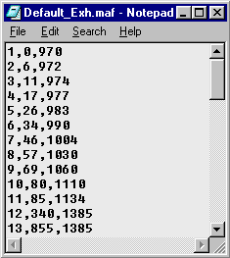
Figure 11: Exhaust manifold area vs. length
The next information the program will need is the exhaust back pressure and temperature boundary data. This information is given to the program as an input file, *.exh (Figure 11). The pressure and temperature data is given at each engine speed. This information can be obtained from engine tests or just using experience and other similar engine data. The back pressure of the exhaust system has a big influence on the gas flow through the engine and should therefore be obtained as early as possible in the design process of an engine or its manifolds.
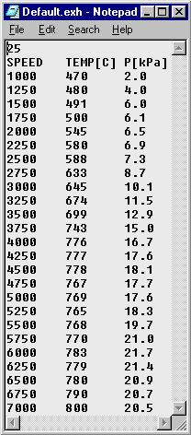
Figure 12: Exhaust gas temperature and pressure
The grid size information and velocities at the exhaust valve that will ensure smooth transition between forward and reverse flow, will not be discussed again for the exhaust. The same principles as discussed for the inlet valve, apply at the exhaust valve. It is a bit easier though, because of the larger pressure differences at the exhaust valve between the exhaust and the cylinder.
All the camshaft information can be entered in the Cams edit tab (Figure 12). The inlet and exhaust valve lift profiles are given to the program as an input file, *.cam. The camshaft model creates the data in this file. The model creates unit duration of zero to one and unit lift of zero to one. This makes it possible to fit the camshaft profile to any opening and closing angle or valve lift value.
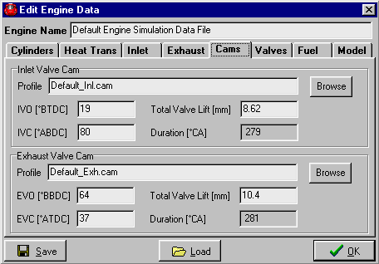
Figure 13: Camshaft information
The inlet and exhaust valve lift, opening and closing angles are all entered in this edit tab. The duration of each camshaft is then calculated from its opening and closing angles.
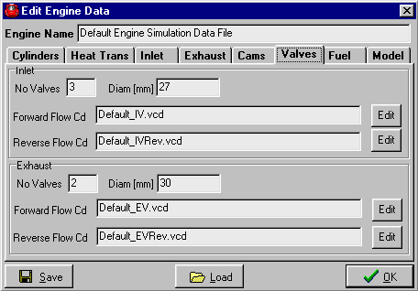
Figure 14: Inlet and exhaust valve data
Information on the valves of the engine is displayed in the Valves tab. In these edit boxes the following needs to be entered (Figure 13):
- Number of inlet and exhaust valves for one cylinder
- Diameter of a single inlet and exhaust valve
Input files containing the discharge coefficient (C_{d}) map data for each valve and for each flow direction, forward or reverse.
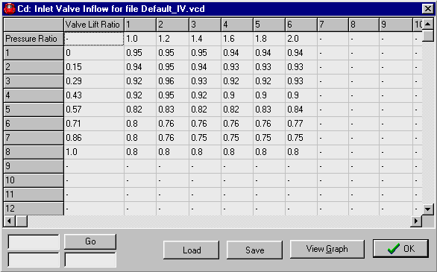
Figure 15: Discharge coefficient map
Clicking Edit displays Figure 14, the C_{d} map data. The information is stored in a text file, *.vcd. The discharge coefficient is a function of the pressure ratio over the valve (row 1 in Figure 14) and the lift ratio (column 1 in Figure 14). These C_{d} values for valves are measured on a steady state flow bench as explained in Chapter 3 of this thesis. The C_{d} map can also be viewed as a 3-dimensional graph in Figure 15 (click View Graph button). These 3 dimensional maps are created for inlet and exhaust valves, and for forward and reverse flow.
The second last edit tab, Fuel, has data on the atmospheric conditions, oil and properties of the fuel (Figure 16). The atmospheric temperature and pressure must be entered in the top left corner. These values are important for the initial values in the manifolds. The viscosity of the oil is used to calculate engine friction.
The following fuel properties are needed:
Stoichiometric A/F Ratio is the amount of air units needed to burn one unit of fuel. Stoichiometric A/F Ratio is also known as the Equivalence Ratio.
Lambda is an indication of the amount of fuel or air left in the exhaust after combustion. In the model it is assumed that all the fuel and air were used for combustion. In a real engine it is quite common for an engine to run with excess fuel, lambda = 0.9, or it is said that the engine is running rich. An engine can also run lean with lambda > 1 and therefore with excess air.
Fuel Energy is a property of the fuel. Petrol usually has a value of 43 MJ/kg.
Fuel Temperature is usually the same as the atmospheric temperature, but can be different when running a physical engine.
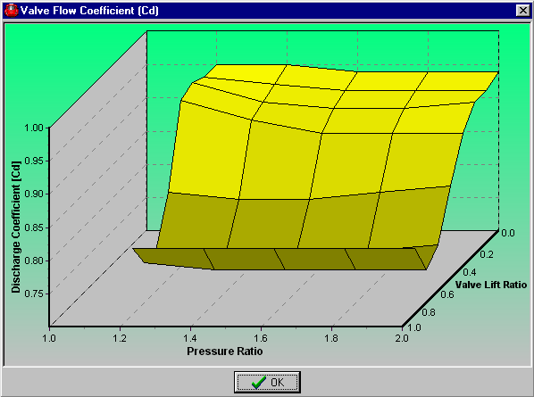
Figure 16: Inlet valve C_{d} map graph
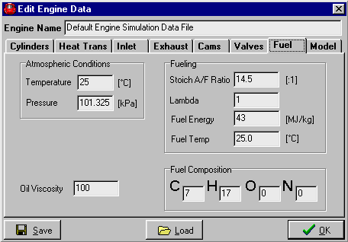
Figure 17: Atmospheric, oil and fuel information
At the moment the fuel composition is not used in the program. It is possible with the 2-zone combustion model though, to predict emissions and for this purpose the composition is necessary.
The last edit tab is called Model (Figure 17). Here the user can make changes to some of the general program options. The program is now only running with the 2-zone combustion model and the 1-zone model is therefore not available anymore. The integration method will default to the Runga Kutte Felberg method, because of the accuracy benefit, but it is also possible to run with the faster Euler integration method. These integration methods are only applicable to the combustion model. Manifold data can also be saved for each grid point at each crank angle degree. The performance data filename can also be changed.
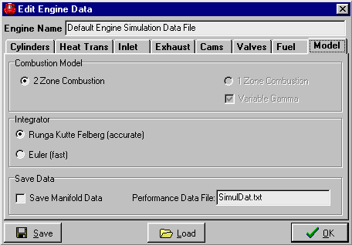
Figure 18: General modelling information
Clicking the Save button saves engine data files. Other engine files are loaded by clicking the Load button. Engine information can also be entered at the top of the Edit Engine Data box. Click the OK button to continue with the simulation.

Single Point Simulation
In Section F-5 it was described how the user creates the necessary engine data file to run a simulation successfully. In this section it is explained how to run a single speed Single Point Simulation.
In the main menu, click Run and then Single Point Simulation. The user sees a small box appear on the display window (Figure 18). This small box gives the user the necessary information to run a single speed simulation. Enter the simulated engine speed as well as the number of iteration cycles (at least 5) and the maximum mass balance value. The program monitors the total iteration cycles and the mass balance values to check when to stop the simulation. Whichever criteria occur first, will stop the simulation. No more than 10 cycles are usually needed to get a reliable answer from the simulation.
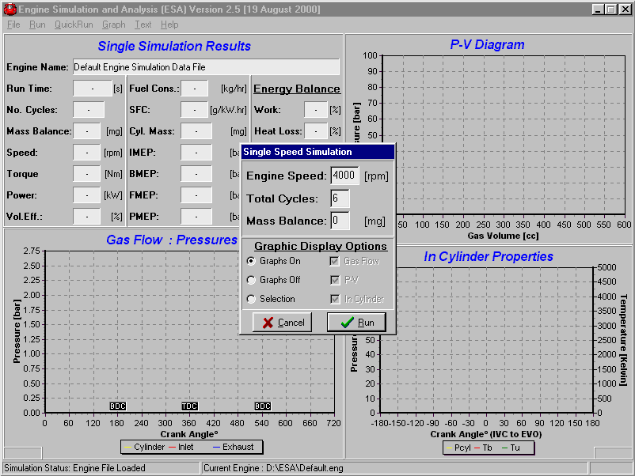
Figure 19: Single speed simulation run
During the runtime of the simulation the user have different options on what must be displayed on the three graphs of the main window. The user has three main options on what the graphs display during run-time (Figure 19).
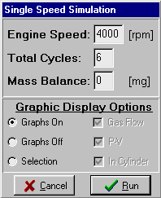 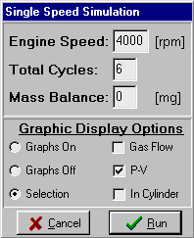 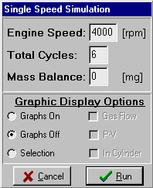
Figure 20: Runtime graphic display options
Checking the Graphs On option causes the simulation to show all the graphs displayed in the main window. Checking Graphs Off causes the simulation to show no online graphics. The Graphs Off simulations run considerably faster, because of the slow speeds of graphic cards compared to computer processors. The last graphic display option is Selection, where the user can specify which graphs to show.
Graphical options can also be changed while the simulation is running or at completion of the simulation. The user can access this option by either going to Graph, Run-Time Graph Options or by right clicking with the mouse on the display window and choosing Options (Figure 20), which displays Figure 21.
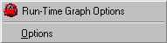
Figure 21: Graph options
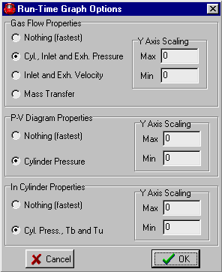
Figure 22: Run-time graph options
Using the edit boxes in Figure 21, the Y-axis scaling of the graphs can be changed. During the simulation the display window will look like Figure 22 (if the Graphs On option is taken). In the top left corner the Run Time will update online and the No. Cycles and Mass Balance will update after each cycle. The other display boxes will only update at the completion of the simulation.
At completion of the simulation, the results are displayed in the rest of the open edit boxes in the upper left corner. The three graphs will also update and display the final answer of the simulation, even if the Graphs Off option was taken during run-time ( Figure ).
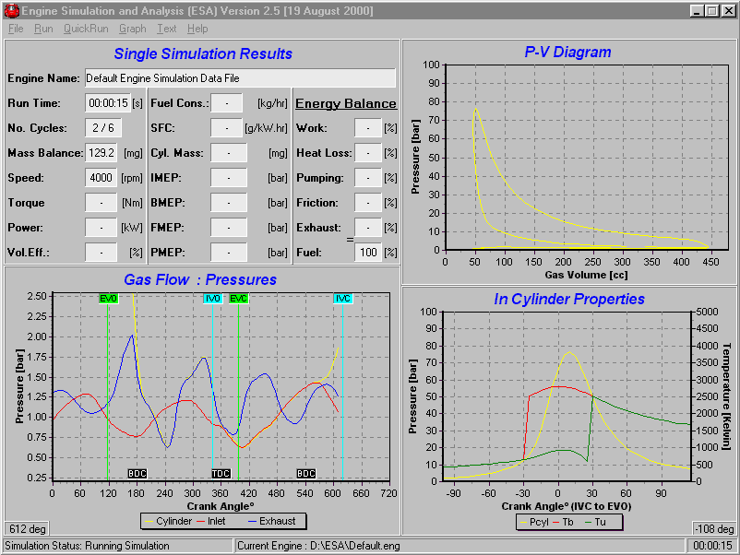
Figure 23: Running simulation
The way in which the simulation results are calculated will not be discussed in this manual. Some of the parameters are discussed in Chapter 4 of this thesis, but more information can be obtained in Ferguson [1], Heywood [2], Heisler [3] and Benson [4].
The display of the graph in the bottom left corner can be changed as discussed earlier. In Figure 21 the default view displays the pressure in the cylinder and at the inlet and exhaust valve. Figure 22 displays the velocity at the inlet and exhaust valve during exhaust blow-down, valve overlap and inlet induction. Figure 23 displays clearly the reverse flow at the exhaust valve and inlet valve. Figure 24 displays the mass transfer at the valves and the trapped mass in the cylinder. The graph also shows how the mass in the cylinder decreases (just after BDC, 540° CA) during reverse flow at the inlet valve. The graph also displays the change in mass from unburned mass to burned mass. These three graphs can be viewed alternatively online during the simulation by using the Run-Time Graph Options.
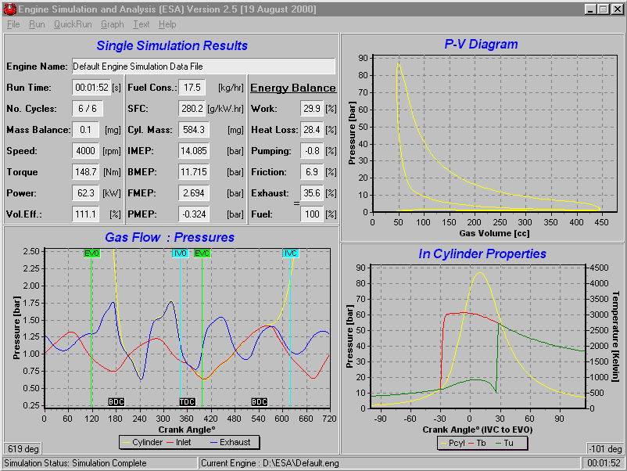
Figure 24: Completed simulation
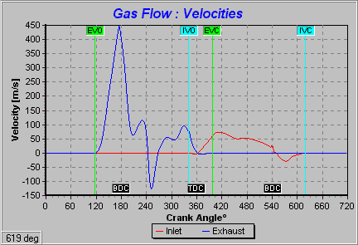
Figure 25: Velocity at the inlet and exhaust valve
The user can also zoom into the PV-Diagram in the top right corner (Figure 25) by clicking with the mouse on the graph and dragging a block, from left too right, around the desired view area. This enables the user to see for example the Pumping Loop of the engine (Figure 26). The original view can again be obtained by dragging a small block, from right too left, with the mouse.
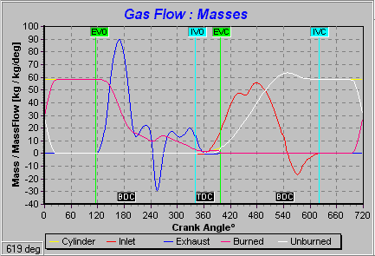
Figure 26: Mass and mass flow
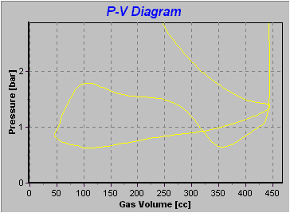
Figure 27: Zoom into PV-diagram
To view or save the results for each crank angle degree, click the Text, PVT Trace menu item. A table (Figure 27) is displayed with the state of each of the simulation variables for each 1° of crank angle. The full 720° (-360° to 360°) of the simulation (4-stroke) for the final cycle of the simulation is displayed. This data can be saved to a text file (default to Lastcyc.txt) using the Save As button and following the standard windows method of file saving. This saves a comma delimited text file (*.txt) with a user defined filename. This data can then be loaded into a spreadsheet program e.g. Excel, and the user can create graphs. It is important to note that this does not include manifold grid information. This information is available in separate text files as explained in Section F-5.
Some of these results can also be displayed graphically using the Graph menu option. Below the Run-Time Graph Options menu item, three available graph types are listed:
Torque Curve displays the resulting torque, power and volumetric efficiency points. This graph is active when different speed points have been simulated with the Multi Point Simulation. More on this graph is shown in the next section on Multi Point Simulation runs.
Valve Opening displays the valve lift profile for the inlet and exhaust valve (Figure 28).
Energy Balance displays the heat loss, work done and pump work of the last simulation cycle (Figure 29).
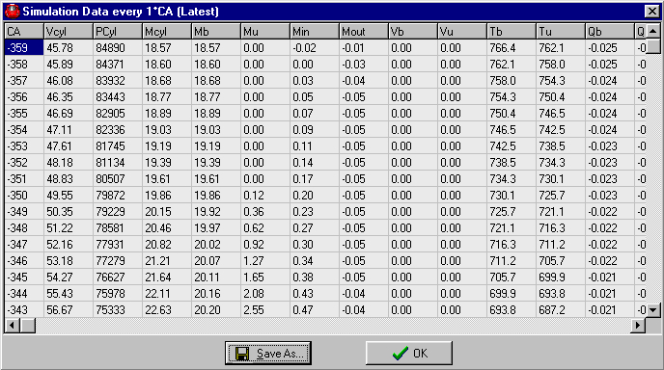
Figure 28: Table with simulation results
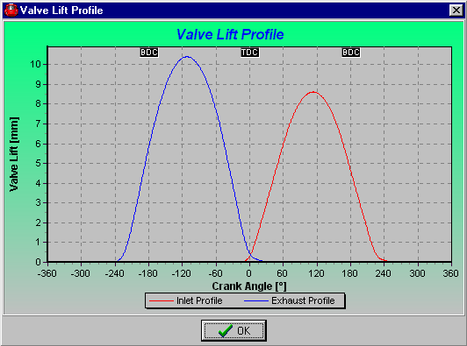
Figure 29: Valve lift profile
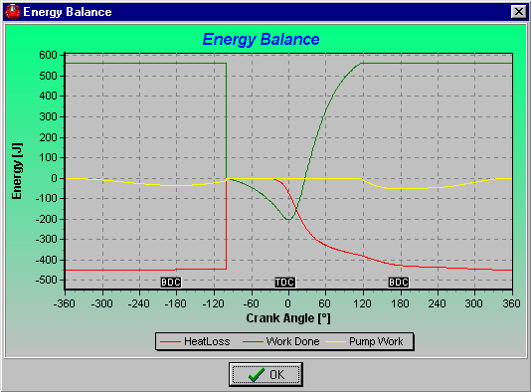
Figure 30: Energy balance
Single Point Simulation runs are very useful when the user is in the process of creating a reliable engine model. It gives the user a quick, but sufficient indication of engine performance and other characteristics to further fine-tune the engine model.

Multi Point Simulation
In Section F-6 it was described how to run a single speed Single Point Simulation. In this section it is described how to do a Multi Point Simulation. This type of simulation gives the user the opportunity to do for example a torque curve at different engine speeds, without running the engine speed points separately using the Single Point Simulation option.
In the main menu, click Run and then Multi Point Simulation. A user box appears on the display window (Figure 30). In the top left corner the engine file in use is displayed. In the table the following can be changed:
Speed can vary for a torque curve or stay constant when testing other engine parameters.
Iters is the amount of iterations or cycles to run for each simulation point.
IManfFile and EManfFile give the option to enter any *.maf text file for the inlet and exhaust manifold. This is used for running manifolds with different lengths and diameters.
ICamFile and ECamFile give the option to load any other camshaft lift profile by specifying a *.cam text file.
IVO, IVC, EVO and EVC can be changed to let the inlet and exhaust valve open or close at different crank angle degrees. It gives the user the opportunity to change the overlap between the inlet and exhaust valve as well as the duration of the inlet and exhaust valve.
IValveLift and EValveLift are used to change the maximum lift of the inlet and exhaust valve.
Spark°BTDC gives the user the opportunity to change the ignition timing of the engine at different engine speeds. It is therefore possible to run a torque curve at different engine speeds and with a specific set of ignition timings.
Burn Angle° gives the option to change the burn angle duration, in crank angle degrees, of the burning fuel.
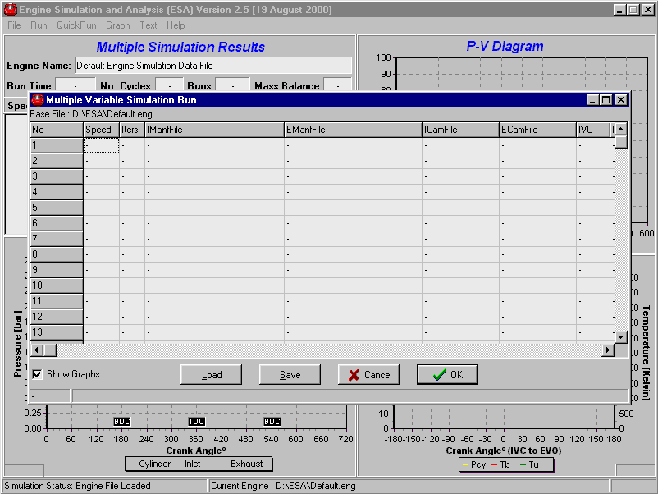Figure 31: Multiple simulation runs
All this information can be stored, using the Save button, in a user defined text file *.msr. Saved text files can also be loaded by clicking the Load button.
The user now has the option to run the Multi Point Simulation. In Figure 30 a text file is displayed that was created to do a torque curve from a 1500 rpm to 6500 rpm in 250 rpm steps. The user also has the option to keep all the graphics on or to have it all off by making a selection in the bottom left corner. The simulation runs faster when the Show Graphs option is not selected.
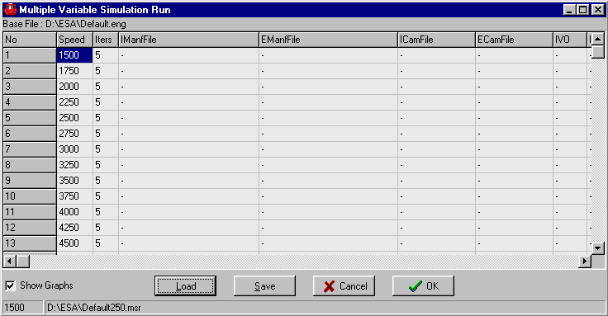Figure 32: Multiple simulation setup for a torque curve
During run-time the user is able to see the following (Figure ):
Total run-time of the simulation.
Number of cycles at the simulated point.
Total number of simulated points and the current simulated point.
Mass balance at the simulated point.
Performance results of the completed simulation points. The results that are displayed are only a few of the more important engine parameters. More extensive results are illustrated in the Text, PVT Trace menu table.
During the run-time of the program and at completion of the simulation, the same graph options, as for a single simulation point, are available. At the completion of the simulation, the displayed data is of the last cycle of the last simulation point. All other menu options as for a single simulation point are still available.
The user might be interested to see the torque curve graphically when running such a Multi Point Simulation. This graph is selected under the Run-Time Graph Options menu item, Torque Curve (Figure XX).
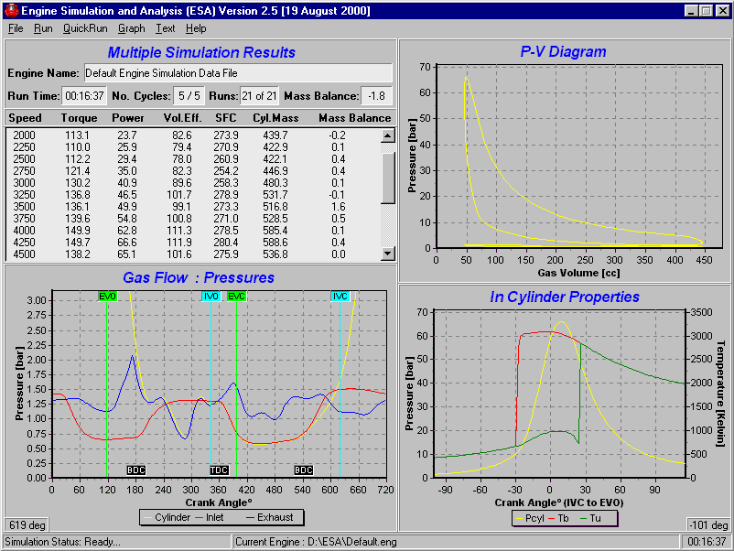Figure 33: Completion of Multi Point Simulation
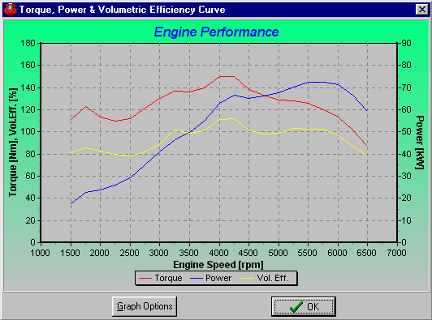
Figure 34: Torque, power and volumetric efficiency curve
Graph options for Figure 34 are available to the user by clicking the Graph Options button. Figure 35 then displays edit boxes to change the maximum and minimum values for the graph axes.
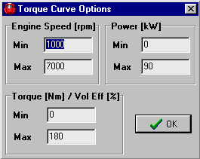
Figure 35: Torque graph options
The Multi Point Simulation option in the ESA program is one of the must powerful and convenient options. It allows the user to do up to 100 simulation points at a time and can therefore gather a substantial amount of data in a relative short space of time. An accurate engine data file will contribute to the accuracy of these results.

General Information
An online user manual is available by clicking the Help, User Manual menu item. More about this program and its creators are displayed in the Help, About menu item (Figure 36).
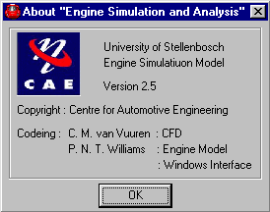
Figure 36: About ESA

